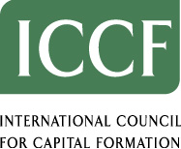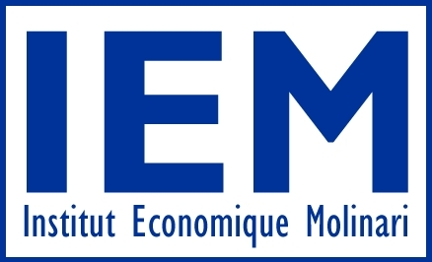

Climate Change Policies and Economic Growth:
What Way Forward to Ensure Both?

A Workshop Co-sponsored by
International Council for Capital Formation, Centre for the New Europe, Istituto Bruno Leoni and Institut Economique Molinari

Wednesday, November 24th, 2004
Place: The European Parliament – Room ASP 1G2

8:30 – 9:00 a.m. Registration and Coffee

9:00 – 9:15 a.m. Introduction

Opening Remarks: Mr. Giles Chichester, MEP – Chairman of the EP
Committee on Industry, Research and Energy

9:15 – 11:00 a.m. Panel I - Climate change: current policies and economic growth

Moderator: Mr. Alejo Vidal Quadras-Roca, MEP – Vice President of the European
Parliament

- Emission Targets and the Lisbon Agenda: Economic impact of the current and future targets on the EU review of model results. Discussion of improvements in emission intensity among major industry economies.
Panellists: Dr. Richard Tol, Hamburg University

- Demographic changes and economic priorities: Expert on the economic priorities of member states and demographic changes, which will increase pressure for strong economic performance.
Panellists: Dr. Gabriel Stein, Chief International Economist, Lombard
Street Research

- Member States’ perspectives:
Panellists: Mrs. Edit Herczog, MEP – Member of the EP Committee
on Internal Market and Consumer Protection

Mrs. Romana Jordan Cizelj, MEP – Member of the EP
Committee on Industry, Research and Energy

Open debate

11:00 – 11:30 a.m. Coffee Break

11:30 – 1:00 p.m. Panel II - A Global Strategy for Climate Change Policy: The Role of Economic Freedom and Technology in the Developing Countries

Moderator: Mrs. Lena Ek, MEP – Member of the EP Committee on Industry,
Research and Energy

- Economic freedom and economic growth in reducing emission intensity and the barriers to technology transfer to developing countries:
Panellists: Dr. Margo Thorning, Managing Director, International
Council for Capital Formation

- Developing countries’ perspectives:
Panellists: Mr. Denis Fontes de Souza Pinto, Brazilian Mission to the EU

Mr. Barun S. Mitra, Liberty Institute, New Delhi, India

Open debate

1:00 – 1:15 p.m. Conclusion

Closing Remarks: Mr. Daniel Caspary, MEP – Member of the EP Committee on International
Trade

